**“Advanced Software Engineering”**

“Project Increment-3”



“ **Smart Health”**

**Team 7: “The Mavericks”**

|  |  |
| --- | --- |
| Bhavesh, Polareddy | 28 |
| Vinay , Santhosham | 32 |
| Naga Sirisha, Sunkara | 40 |
| Vineeth Reddy, Kottam | 15 |

**Introduction to Smart Health**

**Smart Health System**

Some times at emergency conditions we may be not aware of the closest pharmacy stores from our location and also attimes it is difficult for the patient(user) to see the content on the drug, to know its side issues and other content related to the medicine. Thus, here we are trying to develop an application which gives the user with the closest Medical(Pharmacy) stores and to display the patient(user) with the related side issues of the drug and its information with the image of the drug.

**Overall Goal and Objectives**

**Overall Goal:**

Many People face a tough task in reading the content on the medicine, to know its side issues, other realted information about the drug such as dosage. Our application resolves this tasks and make the work easier. This Application will guide the user by showing the side issues of the drug and other information related to the medicine and also displays the nearby pharmacy stores.

**Significance:**

As we can find many applications related to smart health, our application standsout among those other apps. Our application’s significance is to take the information on the drug and convert to text and displays its side issues and warnings on it and drug related information. User can also view the closest Medical stores.

**Objectives:**

In this application, the main objective is to show the drug side issues and make users to see the information drug easily and also finding the nearby medical stores from the users current location.

**Application Features:**

* Login Page for User to login into the Application.
* Registration page where user gets access to login into the application.
* Getting the current location by taking latitude and longitude using Geolocation plugin.
* Getting the location of the nearby pharmacy stores using FourSquare API. Moreover, it will display the store’s location on google maps with the help of Google Maps API.
* Giving access to the user to take image of the drug using camera plugin and display the text and information on the drug.
* Text detection (i.e., name and information of the drug) from the image using Cloud Vision API from Google and it will use one drug database api to find the side effects of the drug and warn the user.

**Project Plan**

**ZenHub issue information for Increment 3:**

For Increment 3 we worked on Storing the regiertation and login credentials in MongoDb. For that we used we created MLAB account to use MongoDb. There we created users and documents to store registered and logged in user details and drug side effects.

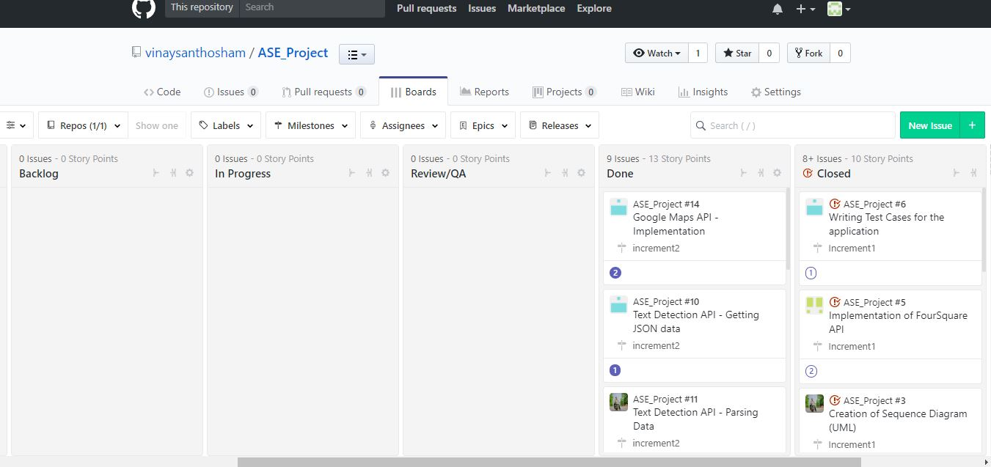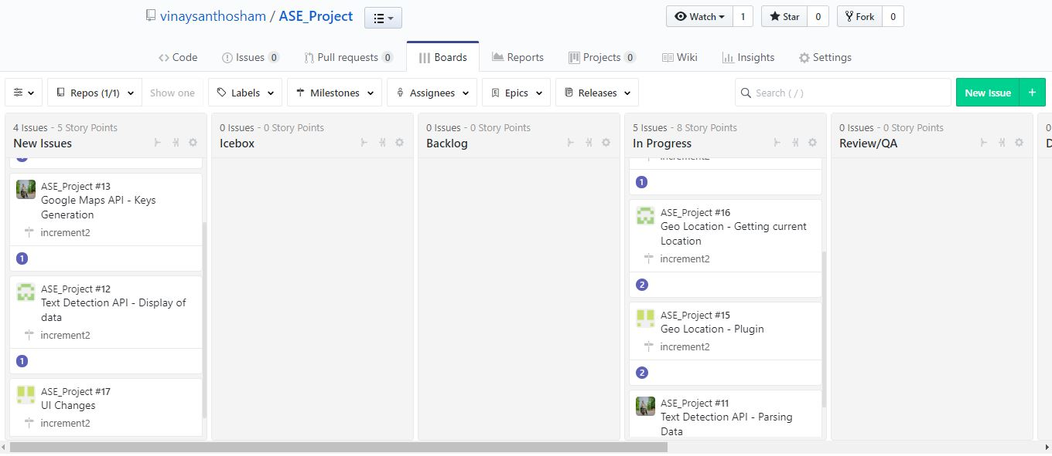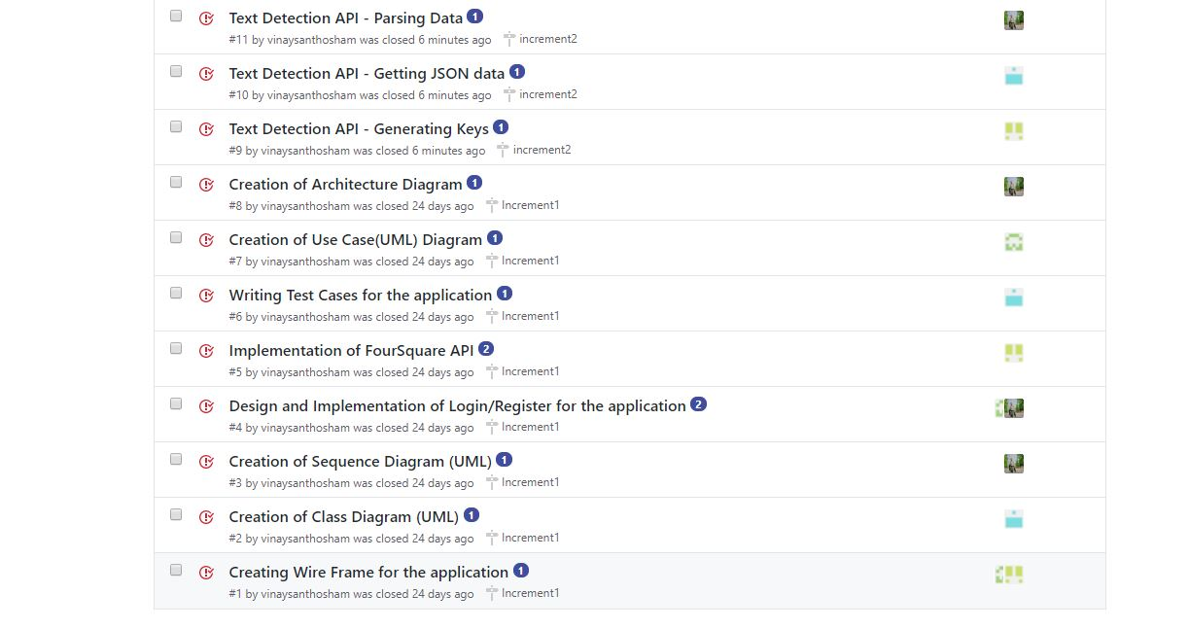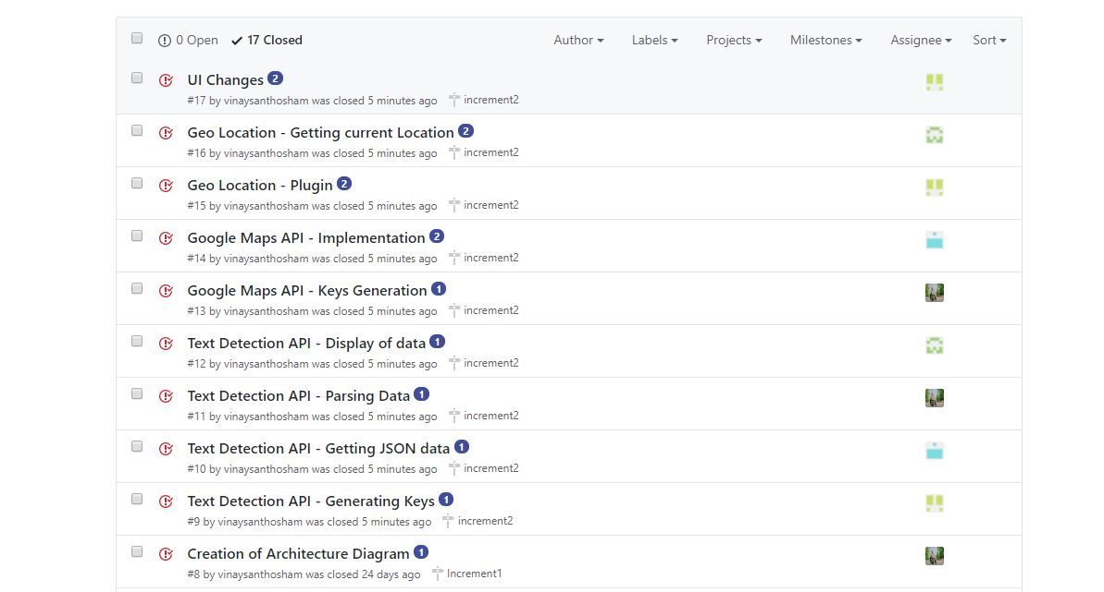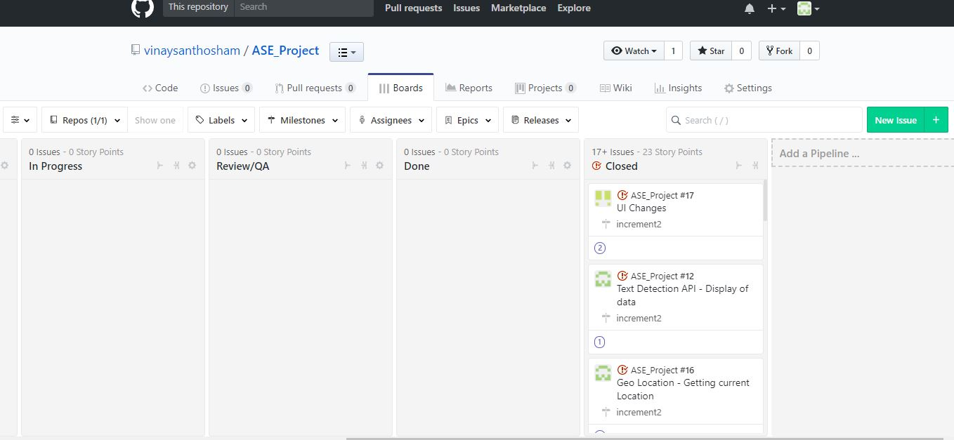

**Burndown Chart for Increment 3:**

The below screenshot shows the burndown chart for increment-3.

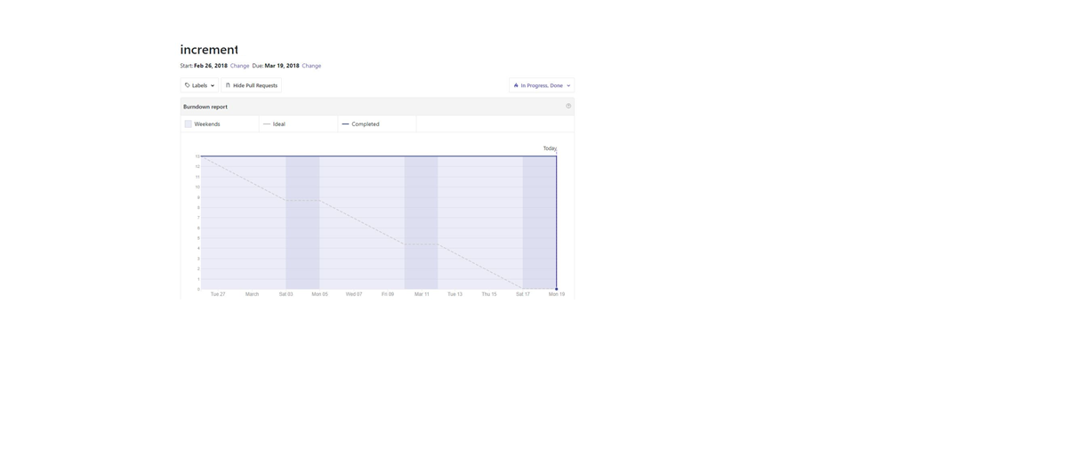

**Increment Report -3**

**Implemented/used API’s/plugins :**

**Plugins**:

**Geolocation:**

To get the latitude and longitude for the users current location.

**Camera:**

To give the access to user to make use of camera.

**FourSquare API:**

It is used to get nearby medical stores by taking the current location of the user. The latitude and longitude of the current location is obtained by taking geolocation cordova plugin.

**Ionic Framework:**

Used Ionic Framework to run the application on web,android,ios.

**Google Maps API:**

Used to get the nearby medical store locations as per users current location and marks it on the google maps.

**Cloud Vision API From Google:**

This API detects the text from the image and displays on the screen.

**Drug Database API:**

This api is used to get the drug related information and its side effects.

* Vuforia- This API is used for presenting AR in our application. It should show the adverse the drug affects on the tablets.

**Design Features of the application**

**Application Wire Frames:**

1. **User Login Page:**

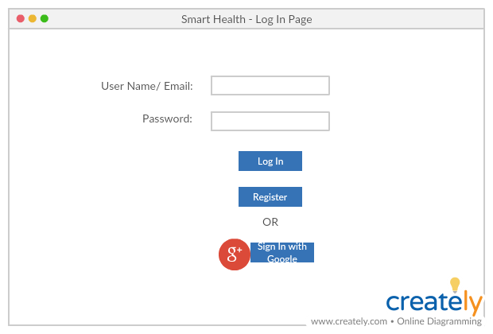

1. **User Registration Page:**

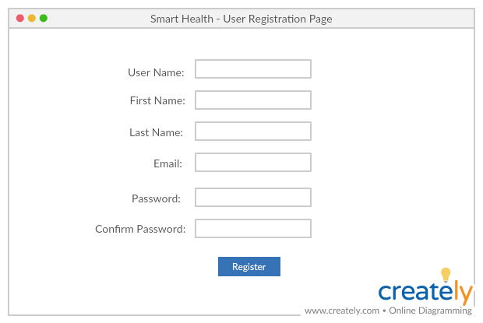

1. **Home Page:**

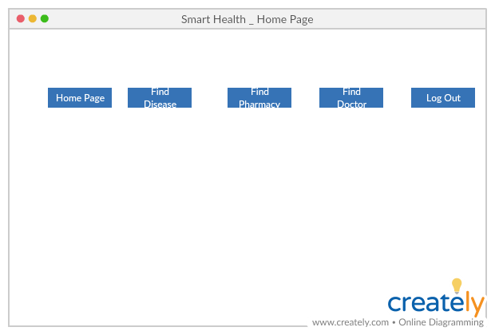

1. **UML Class Diagram:**

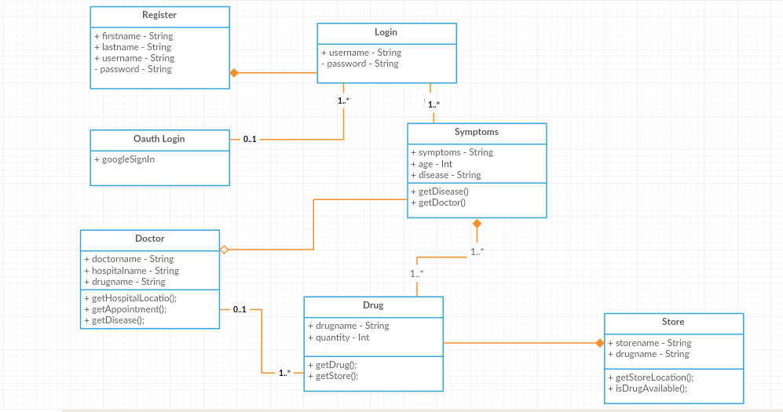

1. **UML Use Case Diagram:**

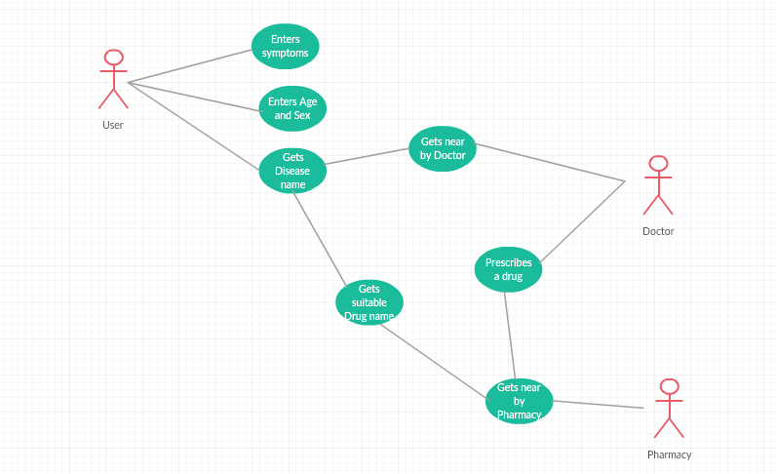

1. **UML Sequence Diagram:**

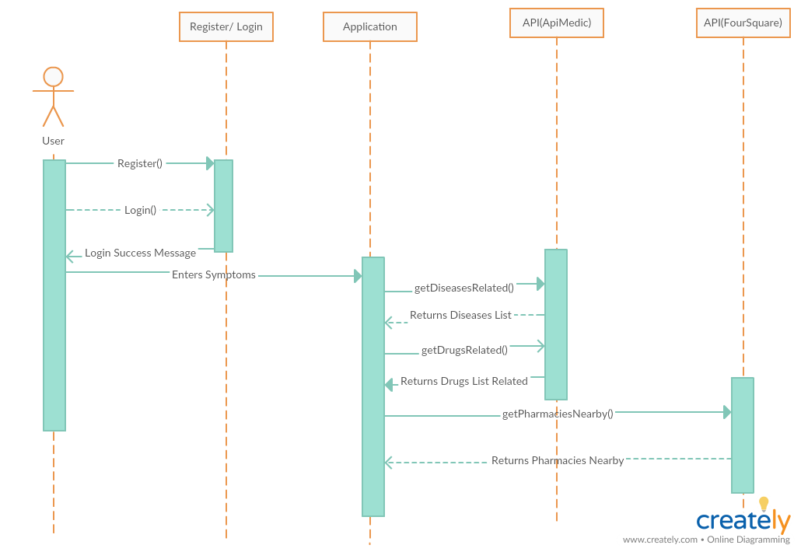

1. **Architecture Diagram:**

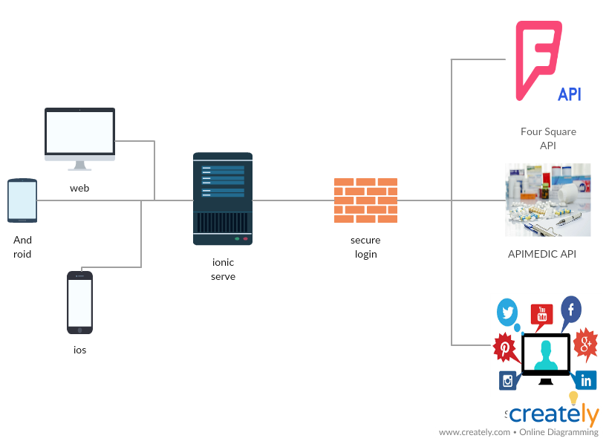

**5.Implementation of the application**

We have implemented our application using Google cloud vision API, Google Maps API and FourSquare API’s. The application process flow is as follows

**User Login Page:**

**1.Login page**

**Input:**Username,Password.

These fields are retrieved from MongoDb.

**Output:** redirection to the homepage.

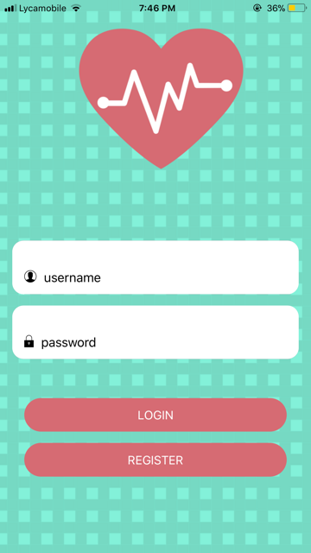

**2. On unsuccessful login :**

On entering invalid credentials an alert box is displayed with a message “Login Unsuccessful”.

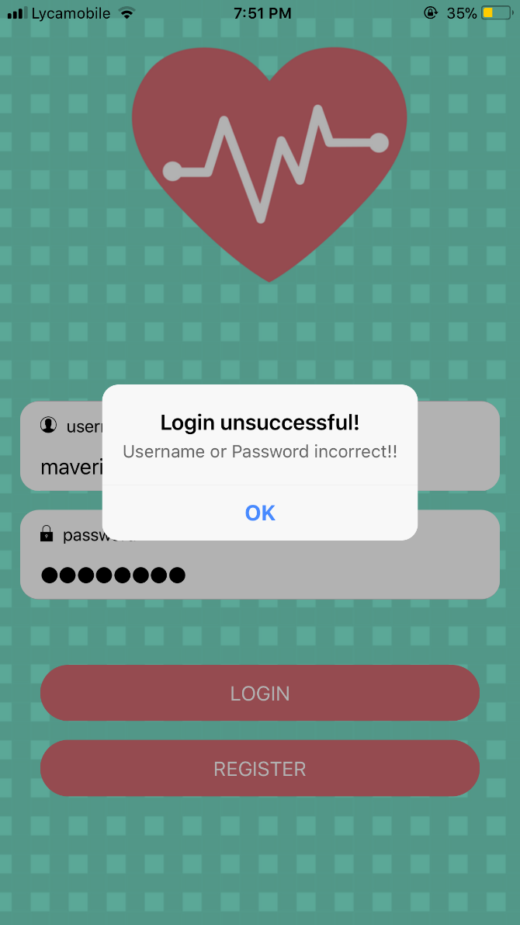

**Registration Page:**

Every user should register to get access to login page by entering the below fields.

**Input:** Name,Email,Username,Password and Confirm Password.

**Output:** After the user enters all the fields and clicks on register ,all the fields are stored in MongoDb.

**1.Following are the screenshots of the registration page.**

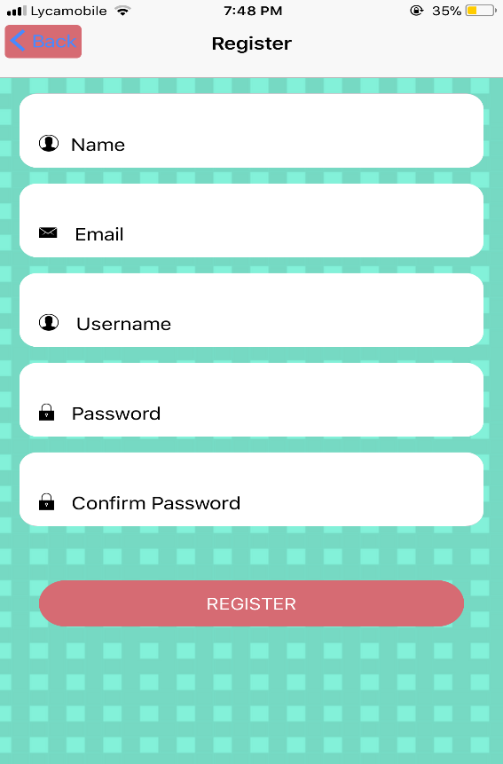

**2. User Registration Successful:**

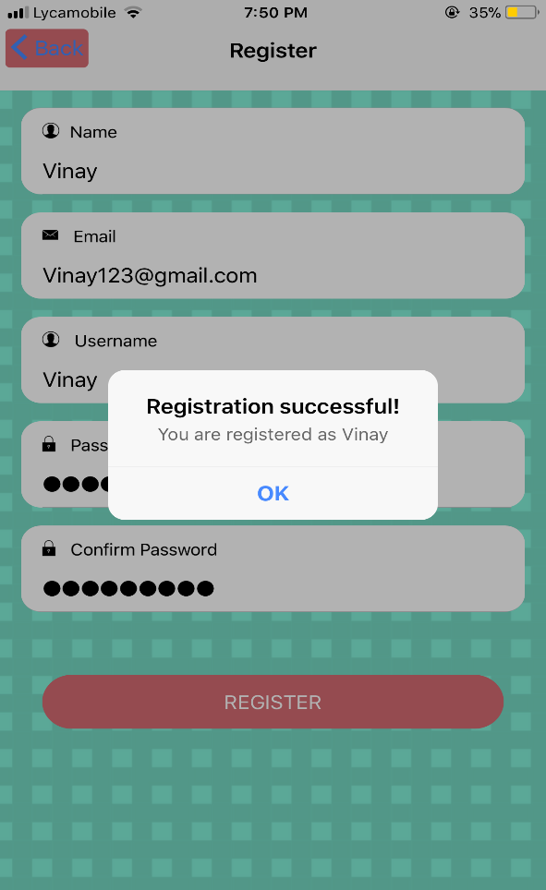

**3. On Entering Invalid passwords**:

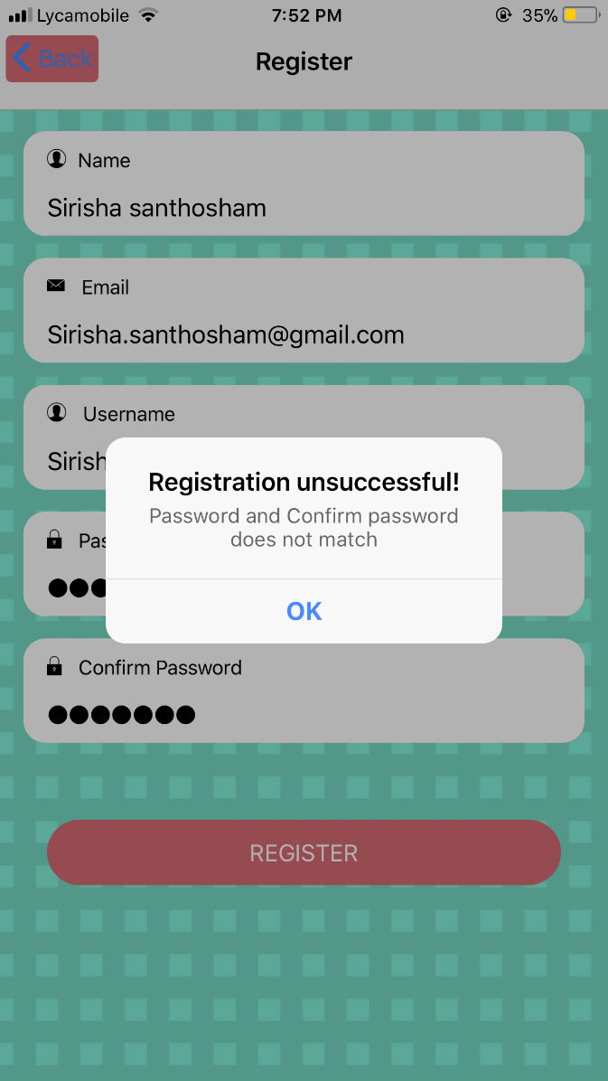

**Home Page:**

In the home page we have implemented two functionalities.

**Get nearest pharmacy locations**

Here, we get locations of nearby medical stores based on the location of the device. It will display the map markers on google maps.

**Drug side effects**

Here the patient/user will take a image of the drug and we will detect the text from the image and we will use the drug API to find the side effects of the drugs.

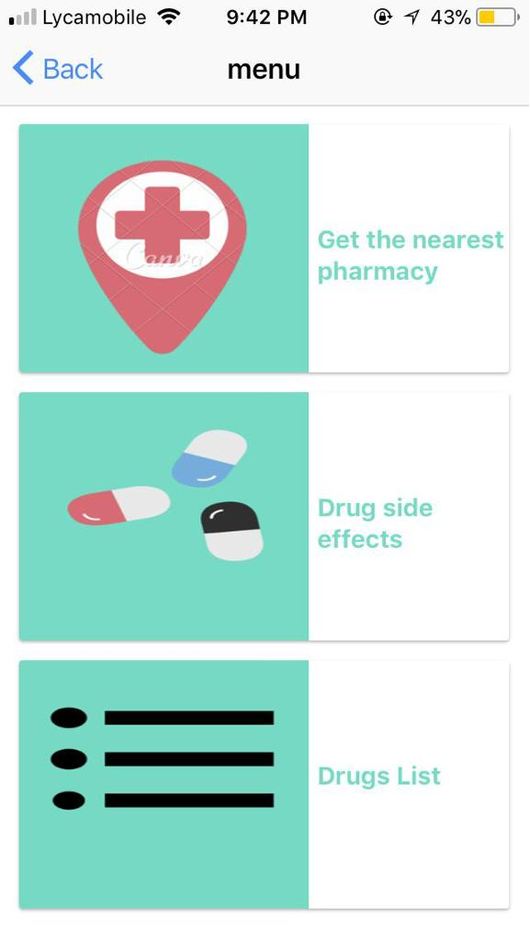

**Get nearest pharmacy location:**

On click of “Get the nearest pharmacy location” ,the application takes the latitude and longitude of the device location.Then the FourSquare API takes the current location as input parameters and retrieves the nearest 5(Number can be changed) pharmacy stores.

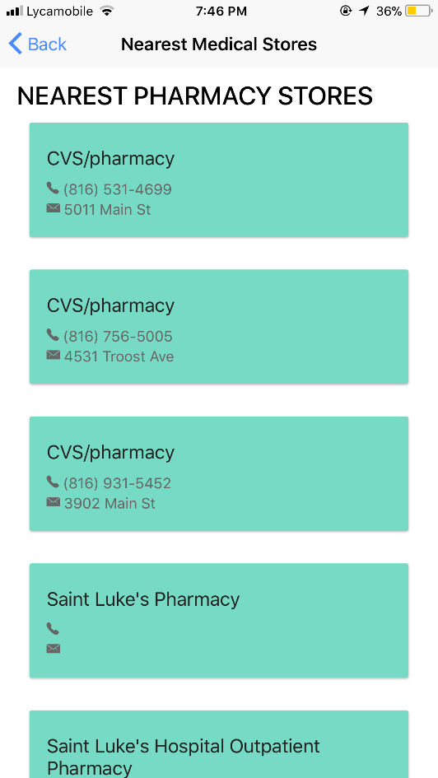

From the result of JSON of FourSquare API,the latitude and longitude are marked on the google maps of the pharmacy stores.

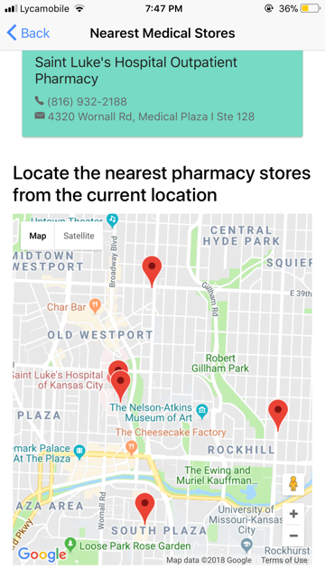

**Drug side effects:**

First we will take the image of the drug and convert that to the text. For the user to click the image, we used camera cordova plugin.

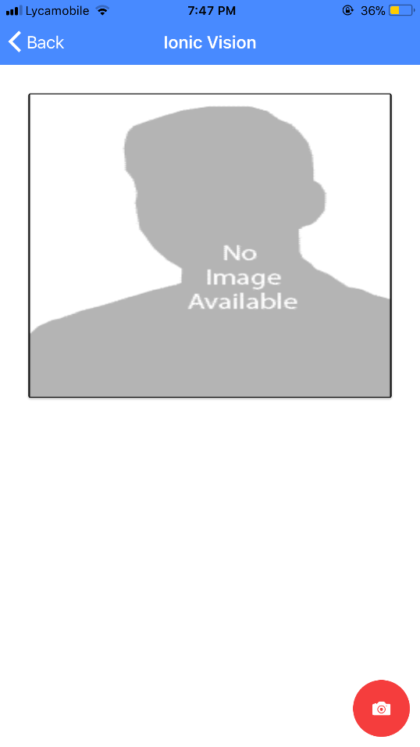 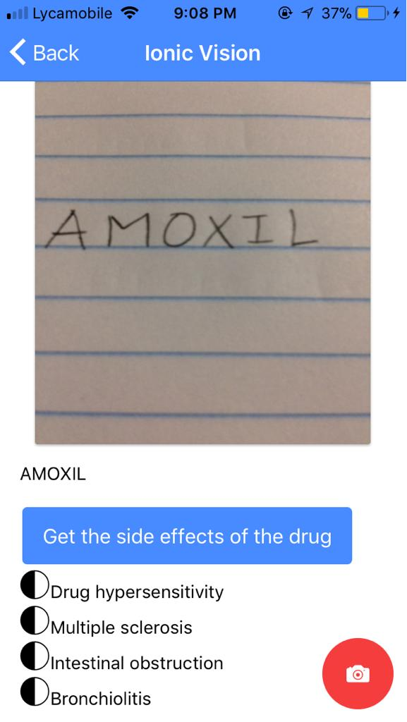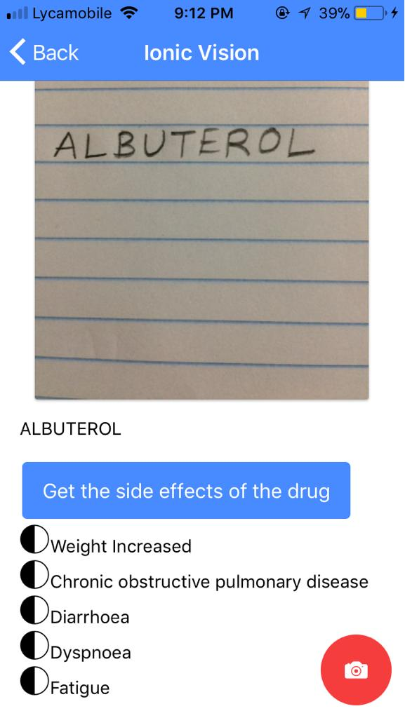

**Drugs List:** On Clicking Drugs List, we get drugs list as in below image. To get the side effects of the drugs we have used the openFDA API and parsed the json from this api.

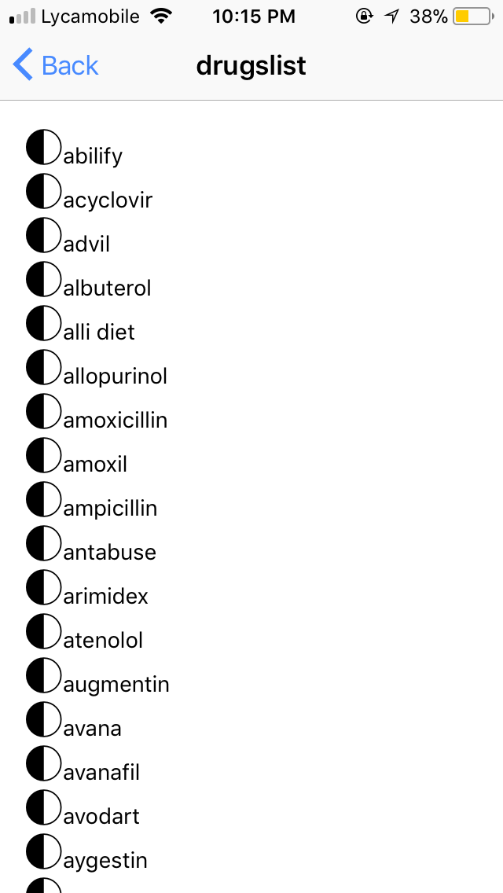

**Vuforia Output:** As of now, we are able to show the text detected from the moving target.

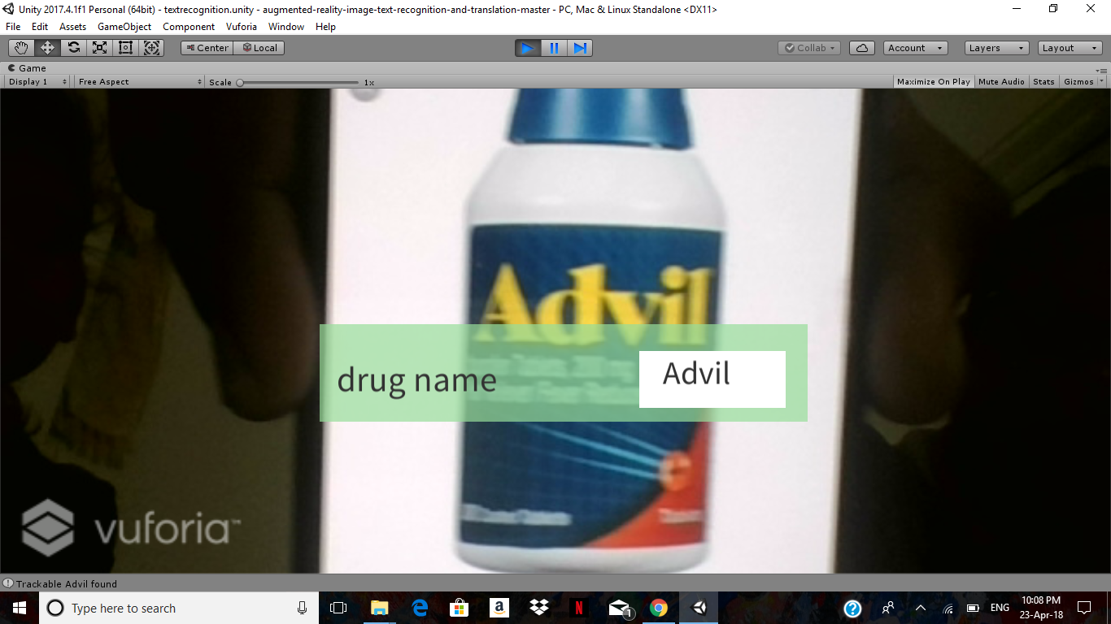

1. **Project Management**

**Technologies Implemented:**

We developed our application with the use of following technologies:

* JavaScript
* Type Script
* HTML5
* CSS3
* Ionic 3

1. **Tasks Completed**

The following tasks are completed as part of increment-3,

* Displaying the nearby medical stores by taking user current location using FourSquare API
* Displaying the map markers on the maps using google Maps API
* Detecting text from the image using Google Cloud Vision API
* Implemented drug database API
* Displaying drug side effects.
* Integrating Augumented reality

1. **Contribution from the team:**

|  |  |
| --- | --- |
| Bhavesh, Polareddy | **25%** |
| Sirisha, Sunkara | **25%** |
| Vinay, Santhosham | **25%** |
| Vineeth Reddy, Kottam | **25%** |

Wiki link: https://github.com/vinaysanthosham/ASE_Project/wiki/Project_Increment_3

1. **Bibliography**
2. <https://foursquare.com/>
3. <http://apimedic.com/>
4. <https://creately.com/app/>
5. <https://cloud.google.com/vision/>
6. <https://www.sitepoint.com/image-recognition-with-the-google-vision-api-and-ionic/>
7. <https://www.iodine.com/api>
8. <https://www.drugs.com/>